RTL-to-GDSII Implementation of a
UART-to-I2C Bridge
Using Open-Source EDA Tools and the SKY130 PDK
A Complete, Reproducible Walkthrough
From Beginner Fundamentals to Industry-Grade Signoff

Toolchain: Icarus Verilog · GTKWave · Yosys · OpenLane · OpenROAD · Magic · KLayout · Netgen
Technology: SKY130A (130 nm) — sky130_fd_sc_hd standard cell library
Target Frequency: 100 MHz | Achieved: 99.8 MHz, 0 setup/hold violations

Table of Contents
1. Introduction 3
2. Prerequisites and Tool Installation 3
3. Project Directory Setup 5
4. RTL Simulation with Icarus Verilog 6
5. Waveform Analysis using GTKWave 6
6. RTL Synthesis with Yosys 8
7. OpenLane Physical Design Flow (RTL-to-GDSII Steps) 9
8. Floorplanning Results 10
9. Placement Results 11
10. Clock Tree Synthesis (CTS) Results 11
11. Routing Results 12
12. Static Timing Analysis (STA) Results 12
13. Power Analysis 12
14. DRC and LVS Verification 14
15. GDSII Generation and Visualization 15
16. Conclusion and Future Work 17
Appendix A: Full Command Reference 18
Appendix B: Glossary (for beginners) 19

1. Introduction
Open-source Electronic Design Automation (EDA) has matured to the point where a complete digital ASIC — from a hardware description in Verilog down to a fabrication-ready GDSII layout — can be built without any commercial CAD license. This project is a full, worked example of that flow: a UART-to-I2C protocol bridge, taken all the way from RTL simulation through synthesis, physical design, and signoff verification on the SkyWater SKY130 open PDK.

Concept: What is RTL-to-GDSII?
"RTL" (Register Transfer Level) is the behavioral Verilog code an engineer writes. "GDSII" is the binary geometry file sent to a semiconductor foundry for fabrication. The steps in between — synthesis, floorplanning, placement, clock-tree synthesis, routing, and signoff — are collectively called the "physical design flow", and are what turns an abstract description of logic into physical shapes on silicon.
The design converts asynchronous UART serial data into I2C bus transactions, and was implemented with the following fully open-source toolchain:
- Icarus Verilog — RTL simulation / compilation
- GTKWave — waveform viewing
- Yosys — RTL synthesis (logic → gate-level netlist)
- OpenLane — automated RTL-to-GDSII flow orchestration
- OpenROAD — floorplanning, placement, CTS, routing, STA engine used inside OpenLane
- Magic — layout view, DRC, and GDS handling
- KLayout — layout viewing and DRC/LVS cross-checking
- Netgen — LVS (layout-vs-schematic verification)
Technology node: SKY130A (130 nm CMOS), sky130_fd_sc_hd standard cell library.

2. Prerequisites and Tool Installation
These steps set up a fresh Ubuntu Linux machine (20.04/22.04 recommended) with every tool used in this guide. Beginners: run these once; you will not need to repeat them for future projects.

2.1 System Packages and Standalone Tools
Icarus Verilog, GTKWave, Yosys, Magic, and KLayout are all packaged for Ubuntu and can be installed directly:
sudo apt update
sudo apt install -y build-essential git python3 python3-pip \
iverilog gtkwave yosys magic klayout
Installs the standalone simulation, synthesis, and layout-viewing tools.
Verify each tool installed correctly:
iverilog -V | head -n 1
gtkwave --version
yosys -V
magic --version
klayout -v

2.2 Docker (required by OpenLane)
OpenLane's classic flow runs inside a Docker container that bundles OpenROAD, Magic, Netgen, and the SKY130 PDK with matched, tested versions.
sudo apt install -y docker.io
sudo systemctl enable --now docker
sudo usermod -aG docker $USER
newgrp docker # refresh group membership in this shell

2.3 OpenLane and the SKY130 PDK
git clone https://github.com/The-OpenROAD-Project/OpenLane.git
cd OpenLane
make # builds/pulls the OpenLane Docker image
make pdk # fetches and builds the SKY130 open PDK via Volare/open_pdks
make test # runs a small built-in design to confirm the flow works
💡 `make test` should finish with a message confirming the sample design passed DRC, LVS, and timing checks. If it fails, re-check the Docker group membership step above (log out/in may be required).

3. Project Directory Setup
OpenLane expects each design to live in its own folder under designs/, containing the RTL source and a configuration file describing the design's name, clock, and target utilization.
cd OpenLane/designs
mkdir -p i2c_uart_bridge/src
cd i2c_uart_bridge
Place the seven RTL source files in src/, then create config.tcl:
set ::env(DESIGN_NAME) i2c_uart_bridge
set ::env(VERILOG_FILES) "dir::src/*.v"
set ::env(CLOCK_PORT) "clk"
set ::env(CLOCK_PERIOD) "10"
set ::env(FP_CORE_UTIL) 50
set ::env(PL_TARGET_DENSITY) 0.55
set ::env(SYNTH_STRATEGY) "AREA 0"
config.tcl — clock period of 10 ns targets the 100 MHz frequency confirmed in Section 11.

3.1 RTL Module Overview
Module | Function
top.v | Top-level integration
uart_rx.v | UART receiver
uart_tx.v | UART transmitter
baud_gen.v | Baud rate generation
fifo.v | Temporary buffering
control_fsm.v | Protocol conversion logic
reg_file.v | Internal register storage
i2c_slave.v | I2C slave communication
The UART receiver captures incoming serial frames and passes them to the control FSM, which interprets commands and drives the I2C slave interface accordingly.

4. RTL Simulation with Icarus Verilog
Before spending any time on physical design, the RTL must be verified functionally. Icarus Verilog compiles the design and its testbench into an executable simulation model.
cd designs/i2c_uart_bridge
iverilog -o sim.out src/*.v tb/*.v
vvp sim.out
gtkwave dump_top.vcd

Concept: Testbench vs. Design
The testbench (files under tb/) is Verilog code that is never synthesized — it only exists to drive stimulus into the design and check its responses during simulation, producing a .vcd waveform dump for GTKWave.
Simulation confirmed:
- UART frame reception
- Register read/write operations
- I2C transaction generation
- Correct protocol conversion across the UART/I2C clock domains

5. Waveform Analysis using GTKWave
GTKWave renders the .vcd dump as timing waveforms so signal transitions can be inspected visually against expected protocol behavior.
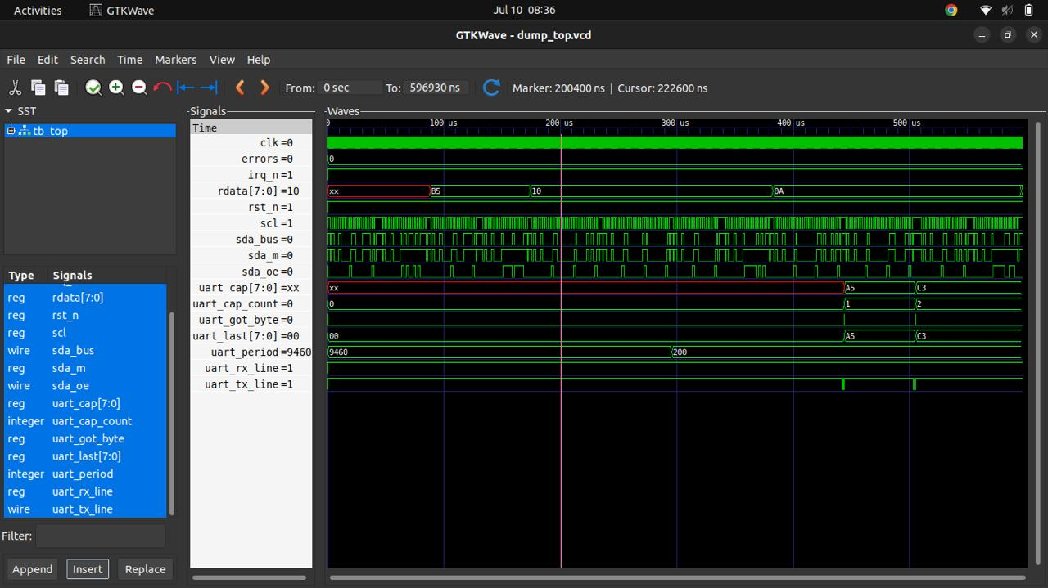
Figure 1. — GTKWave view of dump_top.vcd showing UART capture (uart_cap), UART period, and I2C sda_bus/scl activity
Signals of interest for this design:
- UART RX / TX lines
- Start and stop bits
- Control FSM state transitions
- I2C SDA and SCL lines
- Internal register addresses and data bus activity
The waveform in Figure 1 confirms successful hand-off of data between the UART and I2C clock domains — the captured byte values (e.g. 0xB5, 0xA5, 0xC3) appear correctly on both the uart_cap register and are reflected onto the I2C bus.

6. RTL Synthesis with Yosys
Synthesis translates behavioral Verilog into a gate-level netlist built entirely from SKY130 standard cells. OpenLane calls Yosys internally during its first flow stage, but it can also be run standalone to inspect the resulting network of gates, shown in Figure 2.
yosys -p "synth -top top; write_verilog synth_top.v; show -format dot -prefix yosys_show" src/*.v
xdot yosys_show.dot # opens the interactive gate-level graph viewer
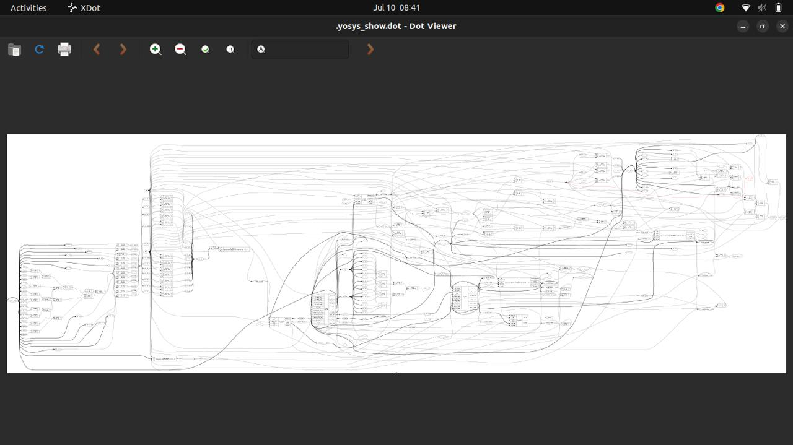
Figure 2. — Synthesized gate-level netlist graph for the UART-to-I2C bridge, viewed with XDot

Synthesis Results
Metric | Value
Synthesized Cell Count | 1,786
Total Cell Count (post-optimization) | 5,314
Logic Depth | 13

Cell Distribution (SKY130 standard cells)
Cell Type | Count | Cell Type | Count
AND | 141 | XOR | 113
NAND | 110 | XNOR | 38
OR | 423 | MUX | 57
NOR | 85 | DFF (flip-flops) | 81

Primary I/O: 385 inputs, 378 outputs.

7. OpenLane Physical Design Flow (RTL-to-GDSII Steps)
With RTL verified and synthesizable, the physical design flow is run as a single automated pipeline:
cd OpenLane
make mount
% ./flow.tcl -design i2c_uart_bridge
`make mount` drops you into the OpenLane Docker container; flow.tcl then runs every stage below in sequence.
💡 The `%` above is the OpenLane Tcl-shell prompt inside the container — do not type it yourself.
OpenLane executes the following stages automatically:
# | Stage | What it does
1 | Logic Synthesis | Translates RTL into a gate-level netlist of SKY130 standard cells (Yosys).
2 | Floorplanning & PDN | Sets die/core dimensions, places I/O pins, builds the power delivery network (VDD/VSS grid).
3 | Placement | Global placement (minimizes wirelength) then detailed placement (legalizes, removes overlaps).
4 | Clock Tree Synthesis | Builds a buffered clock tree (TritonCTS) to minimize skew and insertion delay to all flip-flops.
5 | Routing | Global routing (assigns regions) then detailed routing (assigns tracks/metal layers/vias).
6 | Static Timing Analysis | Verifies setup/hold timing across process corners without dynamic simulation.
7 | Physical Verification | DRC (geometry rules), LVS (layout matches netlist), and antenna checks.
8 | GDSII Generation | Exports the signed-off layout as the final top.gds for fabrication.

8. Floorplanning Results
Floorplanning fixes the physical chip dimensions and utilization target before any cells are placed.
Parameter | Value
Width | 203.78 µm
Height | 201.28 µm
Core Area | 41,016.84 µm²
Die Area | 0.04849 mm²
Floorplan Utilization Target | 50%
Final Utilization Achieved | 58.85%
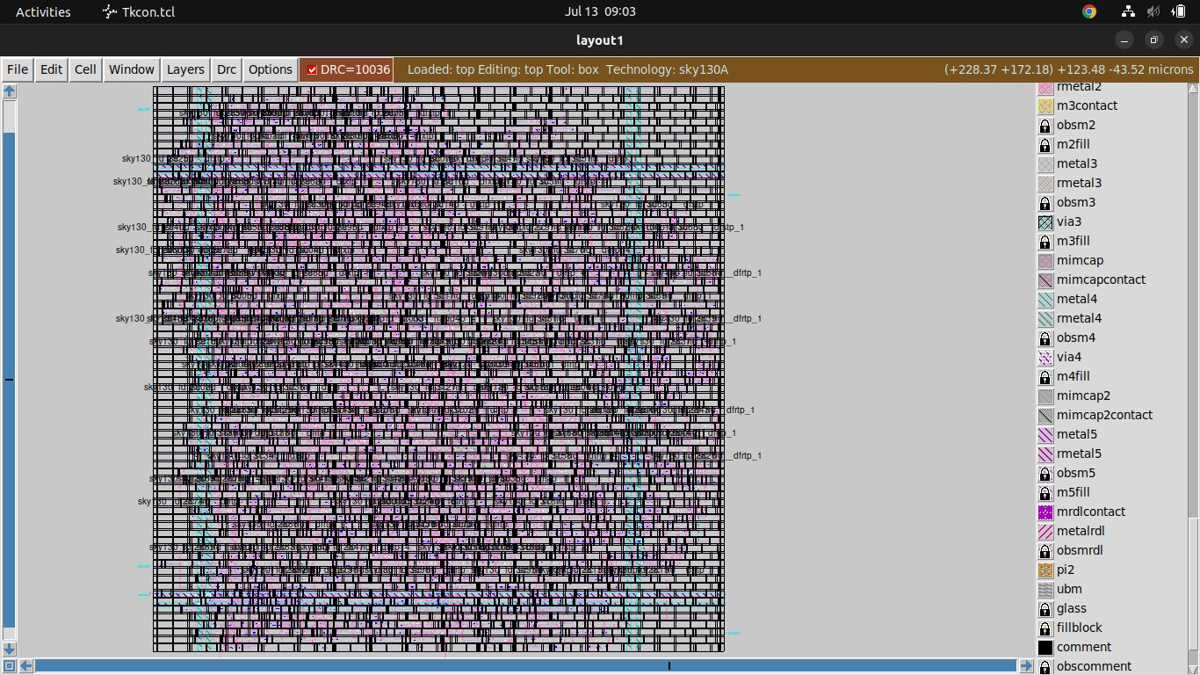
Figure 3. — Full-chip floorplan viewed in Magic — core, I/O ring, and standard-cell rows
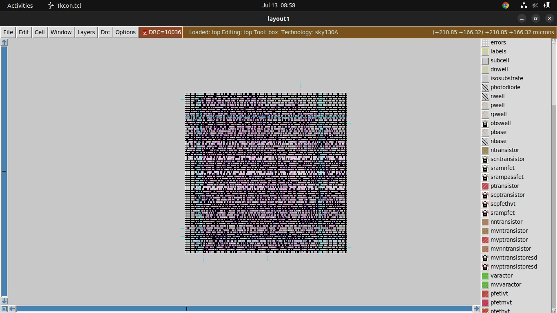
Figure 4. — Floorplan detail in Magic showing the standard-cell placement grid at the transistor layer
To reproduce these Magic views directly:
magic -T sky130A.tech
% load top
% :box
% :view

9. Placement Results
OpenROAD's global and detailed placement engines were run automatically inside the OpenLane flow.
Metric | Value
Total Cells Placed | 5,314
Overlap Violations | 0
Placement Optimization | Completed successfully

10. Clock Tree Synthesis (CTS) Results
Clock Tree Synthesis was performed using TritonCTS, which inserts a balanced tree of clock buffers so every flip-flop receives the clock edge at nearly the same time.
- Clock buffers inserted to balance load
- Clock repeaters added along long clock nets
- Fanout-balancing buffers to equalize sub-tree loads
Result: reduced clock skew, controlled insertion delay, and improved timing closure — reflected in the zero setup/hold violations reported in Section 11.

11. Routing Results
Routing connects every placed cell according to the netlist, first coarsely (global routing) and then with exact track/layer/via assignments (detailed routing).
Metric | Value
Total Wire Length | 48,245 µm
Number of Vias | 13,948
Routing Violations | 0

12. Static Timing Analysis (STA) Results
STA was run across Slow, Typical, and Fast process corners to mathematically validate all setup and hold timing paths.
Parameter | Value
Clock Period Constraint | 10 ns
Target Frequency | 100 MHz
Suggested Clock Frequency | 99.8 MHz
Critical Path Delay | 1.39 ns
Worst Negative Slack (WNS) | 0 ns
Total Negative Slack (TNS) | 0 ns
Hold Violations | 0
Setup Violations | 0
Maximum Fanout Constraint | 10
Fanout Violations | 25
💡 Fanout violations (25) are a design-quality warning, not a timing failure — some nets drive more loads than the recommended limit of 10. Setup and hold themselves are fully clean (0 violations), so the chip meets timing as-is; the fanout warning is a candidate for future optimization (see Section 16).

Concept: Setup vs. Hold vs. Slack
Setup time checks that data arrives before the next clock edge; hold time checks that data doesn't change too soon after a clock edge. "Slack" is the margin between required and actual arrival time — 0 ns slack with 0 violations means every path meets its constraint with no margin to spare, i.e. the design is timing-closed exactly at its target frequency.

13. Power Analysis
Power was estimated after parasitic extraction, across the same three process corners used for STA.
Process Corner | Internal (mW) | Switching (mW) | Leakage (mW) | Total (mW)
Slow Corner | 0.00191 | 0.00066 | 0.0000158 | 0.002586
Typical Corner | 0.00243 | 0.000856 | 0.000000301 | 0.003286
Fast Corner | 0.00280 | 0.00102 | 0.000000313 | 0.003820
Total power stays under 4 µW across all corners — well within the budget of a low-power embedded communication peripheral.

14. DRC and LVS Verification
Physical verification confirms the layout is both manufacturable (DRC) and electrically equivalent to the synthesized netlist (LVS).
Check | Tool(s) | Result
Design Rule Check (DRC) | Magic | Pass — 0 violations
Design Rule Check (DRC) | KLayout | Pass — 0 violations
Layout vs. Schematic (LVS) | Netgen | Pass — 0 errors
Antenna Check | Magic / OpenROAD | Pass — 0 violations
XOR (layout diff check) | KLayout | Pass
To reproduce DRC/LVS signoff checks manually inside the OpenLane container:
% run_magic_drc
% run_magic_spice_export
% run_lvs
% run_antenna_check

15. GDSII Generation and Visualization
The final stage exports the fully placed-and-routed, DRC/LVS-clean layout as a GDSII stream file — the industry-standard format sent to a foundry for fabrication.
# generated automatically by OpenLane at:
results/final/gds/top.gds

15.1 Viewing the Layout in KLayout
klayout results/final/gds/top.gds
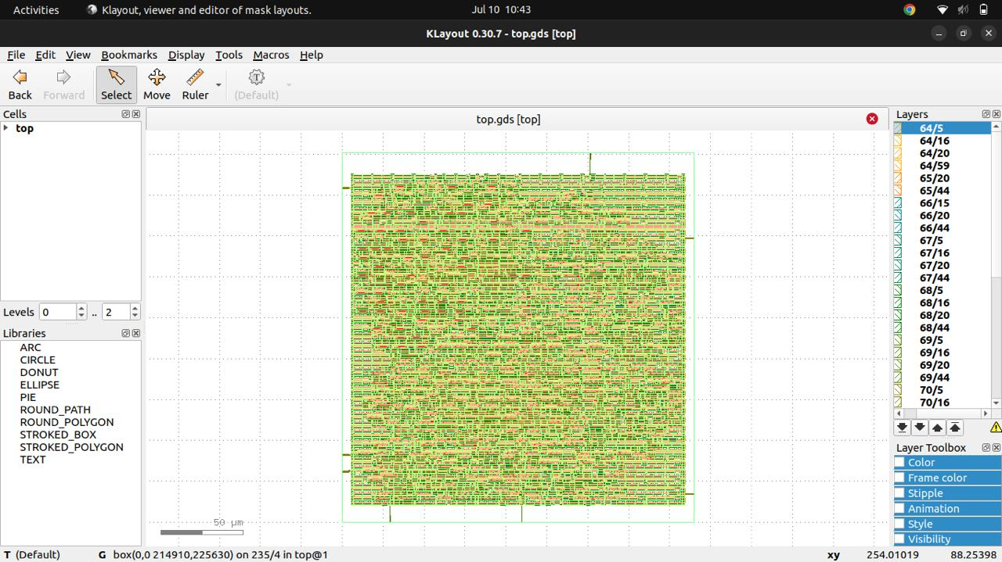
Figure 5. — top.gds opened in KLayout with default layer colors, no custom layer map applied
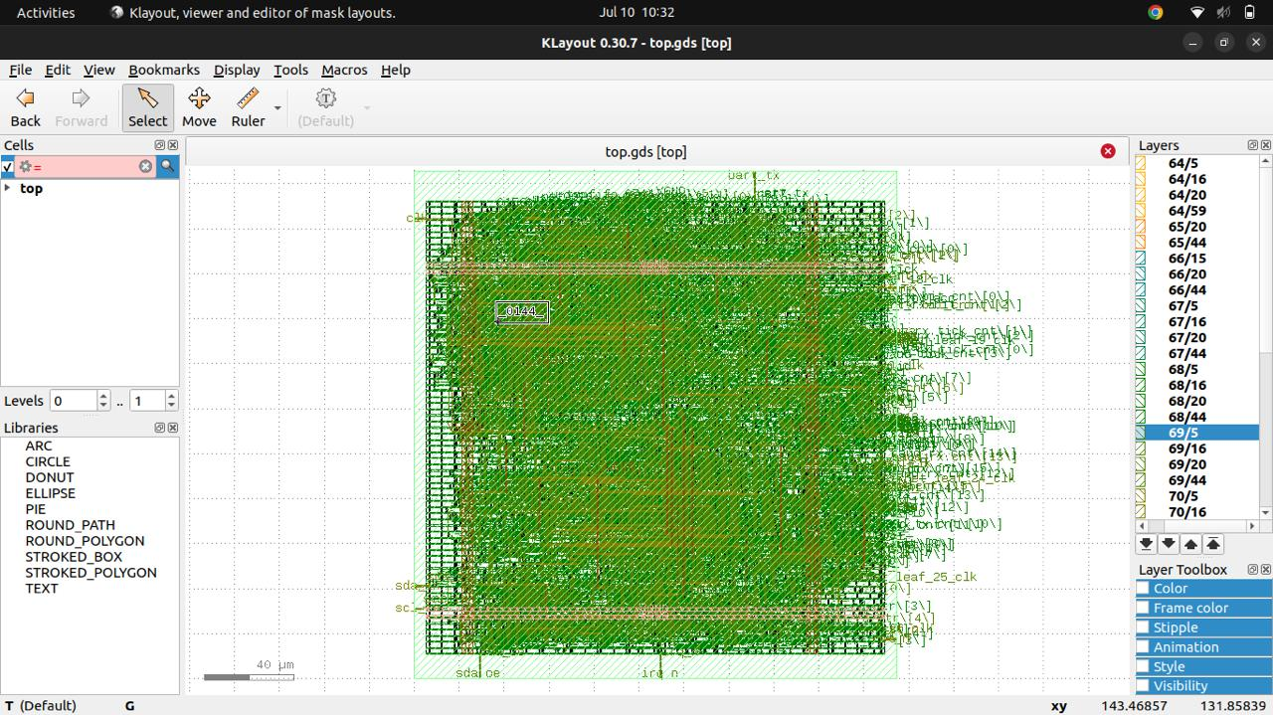
Figure 6. — top.gds in KLayout with the SKY130 layer map loaded — metal, via, and diffusion layers colorized and net labels visible
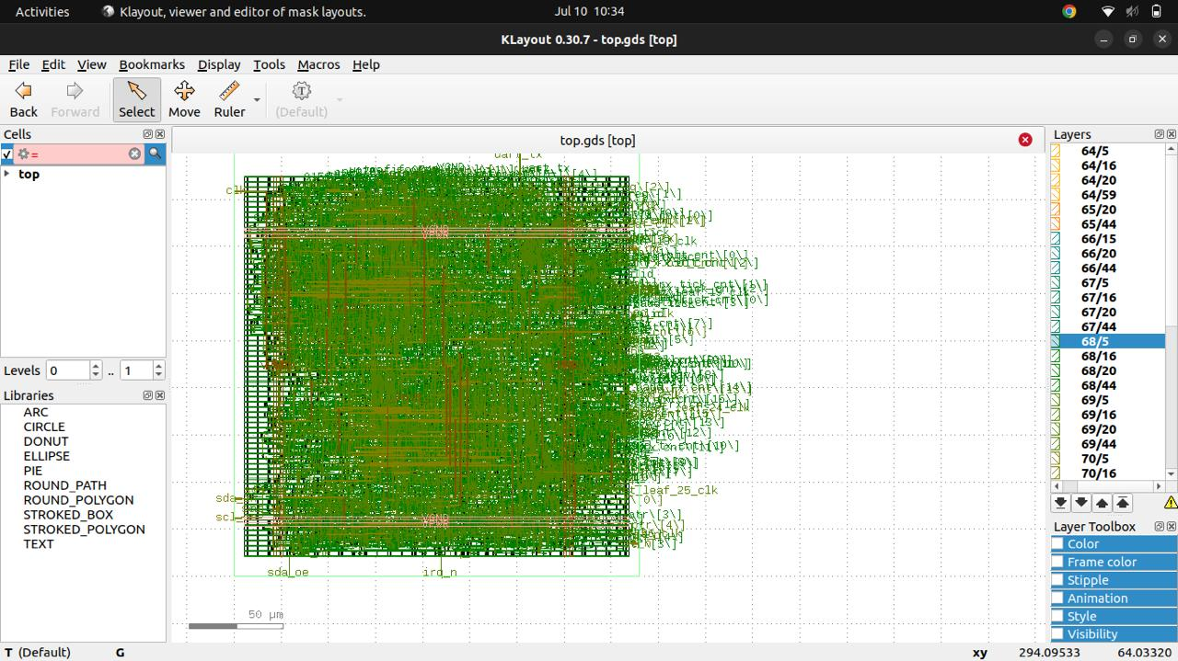
Figure 7. — Zoomed KLayout view showing routed nets, standard-cell rows, and I/O pin labels (sda, scl, irq_n, clk)

15.2 Viewing / Verifying the Layout in Magic
magic -T sky130A.tech
% gds read top.gds
% load top
💡 Use Magic when you need to interactively probe layers, run DRC (`:drc check`), or extract SPICE for LVS. Use KLayout for fast viewing, layer-map based colorization, and independent DRC/XOR cross-checks against Magic's results.

16. Conclusion and Future Work
This project demonstrated a complete RTL-to-GDSII implementation of a UART-to-I2C bridge using an entirely open-source EDA toolchain, meeting timing closure at 100 MHz with zero setup and hold violations across all process corners.

Achievements
- Functional RTL verification via Icarus Verilog / GTKWave
- Successful synthesis to SKY130 standard cells via Yosys
- Timing closure at 100 MHz (0 setup/hold violations, all corners)
- DRC-clean and LVS-clean layout (Magic, KLayout, Netgen)
- Signed-off GDSII generation, ready for tapeout submission

Future Work
- Multi-master I2C support
- DMA integration for the FIFO buffer
- Low-power optimization and clock gating
- Multi-voltage domain implementation
- Reducing the 25 max-fanout warnings identified in Section 12
- Advanced protocol bridging, e.g. SPI-to-I2C or UART-to-SPI

Appendix A: Full Command Reference
Every command used across this guide, in execution order, ready to copy-paste.

A.1 One-time environment setup
sudo apt update
sudo apt install -y build-essential git python3 python3-pip \
iverilog gtkwave yosys magic klayout docker.io
sudo systemctl enable --now docker
sudo usermod -aG docker $USER
newgrp docker
git clone https://github.com/The-OpenROAD-Project/OpenLane.git
cd OpenLane
make
make pdk
make test

A.2 Simulation
cd designs/i2c_uart_bridge
iverilog -o sim.out src/*.v tb/*.v
vvp sim.out
gtkwave dump_top.vcd

A.3 Standalone synthesis inspection (optional)
yosys -p "synth -top top; write_verilog synth_top.v; show -format dot -prefix yosys_show" src/*.v
xdot yosys_show.dot

A.4 Full physical design flow
cd OpenLane
make mount
% ./flow.tcl -design i2c_uart_bridge

A.5 Layout visualization and signoff
klayout results/final/gds/top.gds
magic -T sky130A.tech
% gds read top.gds
% load top
% run_magic_drc
% run_lvs

A.6 Report extraction
cat ~/openlane_designs/i2c_uart_bridge/runs/RUN_<timestamp>/reports/metrics.csv
cat ~/openlane_designs/i2c_uart_bridge/runs/RUN_<timestamp>/reports/signoff/33-sta-rcx_nom/multi_corner_sta.summary.rpt
cat ~/openlane_designs/i2c_uart_bridge/runs/RUN_<timestamp>/reports/signoff/33-sta-rcx_nom/multi_corner_sta.power.rpt
cat ~/openlane_designs/i2c_uart_bridge/runs/RUN_<timestamp>/reports/signoff/33-sta-rcx_nom/multi_corner_sta.checks.rpt
💡 Replace RUN_<timestamp> with the actual run folder name OpenLane created (e.g. RUN_2026.07.10_04.58.13), visible under designs/i2c_uart_bridge/runs/ after flow.tcl completes.

Appendix B: Glossary (for beginners)
Term | Meaning
RTL | Register Transfer Level — behavioral Verilog/VHDL code describing logic in terms of registers and the operations between them.
Netlist | A list of standard-cell instances and the wires (nets) connecting them, produced by synthesis.
Standard cell | A pre-designed, pre-characterized logic gate (AND, DFF, etc.) from the PDK's cell library, used as a building block.
PDK | Process Design Kit — the foundry-specific rules, models, and cell libraries needed to design for a given fabrication process.
Floorplan | The physical outline (die/core size) and macro/pin placement defined before detailed placement.
Placement | Assigning an exact (x, y) location to every standard cell.
CTS | Clock Tree Synthesis — building the buffered network that distributes the clock signal with minimal skew.
Routing | Creating the physical metal wires and vias that realize the netlist's connections.
DRC | Design Rule Check — verifies the layout obeys the foundry's manufacturable geometry rules.
LVS | Layout Versus Schematic — verifies the layout's extracted netlist matches the synthesized netlist.
STA | Static Timing Analysis — checks setup/hold timing on every path without running a simulation.
GDSII | The binary layout file format sent to a foundry for fabrication.
Slack | Timing margin: (required arrival time) − (actual arrival time). Negative slack is a violation.

